**ABSTRACT**

The Digital Time Capsule is an innovative project designed to preserve and share personal and cultural memories in a digital format for future generations. By utilizing advanced technology, individuals can upload photos, videos, messages, and other digital artifacts, creating a rich tapestry of contemporary life.

The capsule is securely stored in a cloud-based environment, ensuring long-term accessibility and protection against data loss. Users can set specific release dates or milestones, allowing future recipients to experience the past in a meaningful way.

This initiative fosters intergenerational connections and encourages reflection on shared histories. Ultimately, the Digital Time Capsule serves as a bridge between the present and the future, celebrating the essence of human experience.

**INTRODUCTION**

The Digital Time Capsule project seeks to harness the power of technology to create a repository of personal and cultural memories that can be shared with future generations. In an age where digital content is rapidly created and consumed, the importance of preserving our stories, sentiments, and experiences has never been more critical. This project invites individuals to contribute their unique narratives by uploading a variety of digital artifacts, such as photos, videos, and personal messages. The aim is to encapsulate the essence of contemporary life, capturing moments that might otherwise fade into obscurity. With a secure, cloud-based storage system, the Digital Time Capsule ensures that these cherished memories are safeguarded against the challenges of time and technological change. Users can designate specific release dates or milestones for their capsules, adding an element of anticipation and connection between past and future. By fostering intergenerational dialogue and understanding, this initiative enriches our collective history. Ultimately, the Digital Time Capsule empowers individuals to reflect on their legacies while contributing to a shared cultural tapestry. In this way, it serves as a bridge between generations, celebrating the enduring nature of human experience.

**PURPOSE**

The purpose of the Digital Time Capsule is to preserve personal and cultural memories in a way that is accessible to future generations. By enabling individuals to upload digital artifacts—such as photographs, videos, and personal messages—the project aims to capture the richness of contemporary life and the diverse experiences of people today. It seeks to safeguard these memories against the rapid changes in technology and society, ensuring that future audiences can connect with and learn from the past. Additionally, the Digital Time Capsule encourages intergenerational dialogue, inviting recipients to reflect on their heritage and the values that shaped it. The project aims to foster a sense of community and continuity, bridging the gap between different generations. By allowing users to set specific release dates, it creates a sense of anticipation and significance surrounding the sharing of memories. Ultimately, the Digital Time Capsule aspires to celebrate the human experience and inspire a deeper appreciation for the stories that define us. It serves as a reminder of the importance of legacy, connection, and the impact of our shared histories. Through this initiative, we hope to enrich future societies with insights and lessons drawn from the past.

**OBJECTIVES**

The primary objective of the Digital Time Capsule is to create a sustainable platform for preserving and sharing personal and cultural memories in a digital format. It aims to empower individuals to document their lives and experiences, ensuring that their unique narratives are not lost to time. By facilitating the upload of diverse digital artifacts—such as photos, videos, and personal letters—the project seeks to capture the essence of contemporary society. Another key objective is to ensure long-term accessibility of these memories through secure, cloud-based storage, protecting them from technological obsolescence. The project also aims to foster intergenerational connections by allowing users to designate specific release dates for their capsules, creating opportunities for future audiences to engage with the past. Additionally, it strives to promote reflection on the significance of individual and collective histories, encouraging users to consider their legacies. By facilitating community engagement, the Digital Time Capsule hopes to enrich cultural dialogue and understanding. Ultimately, the objective is to celebrate and document the human experience, contributing to a shared repository of stories that can inspire and educate future generations. Through these efforts, the project aspires to create a lasting impact on how we perceive and remember our lives and histories.

**USER INSTRUCTIONS**

Here are the user instructions for the Digital Time Capsule:

1. **Create an Account**: Visit the Digital Time Capsule website or app and sign up by providing your email address and creating a secure password. Verify your account through the confirmation email sent to you.
2. **Log In**: Once your account is created, log in using your credentials to access the Digital Time Capsule dashboard.
3. **Start a New Capsule**: Click on the "Create New Capsule" button. Choose a title for your capsule that reflects the theme or purpose of the memories you wish to preserve.
4. **Upload Digital Artifacts**: Begin uploading your digital artifacts. You can add photos, videos, audio messages, and written notes. Follow the on-screen prompts to select files from your device and ensure they meet the supported formats.
5. **Add Descriptions**: For each artifact, provide a brief description or context to enhance understanding. Describe the significance of the memory or the event, including any important dates or names.

**6.Set Release Dates**: Choose a specific date or milestone for the capsule to be revealed, whether it’s a birthday, anniversary, or a significant future year. This adds an element of anticipation for recipients.

**7.Review and Edit**: Before finalizing your capsule, review all uploaded content and descriptions. Make any necessary edits to ensure everything is accurate and meaningful.

**8.Save and Secure**: Once satisfied, save your capsule. Ensure you have enabled secure storage options for data protection, including any backup options available.

**9.Share with Others**: If desired, invite family members or friends to contribute to a shared capsule or to view specific capsules. You can share access via email invitations or dedicated links.

**10.Reflect and Update**: Regularly revisit your capsules to reflect on your memories and add new digital artifacts. Keep the content fresh and relevant, allowing your story to evolve over time.

**SAMPLE CODE:**

import json

from datetime import datetime

def save_capsule(message, reveal_datetime):

with open("time_capsule.json", "w") as f:

json.dump({"message": message, "reveal_datetime": reveal_datetime.isoformat()}, f)

def load_capsule():

try:

with open("time_capsule.json", "r") as f:

return json.load(f)

except FileNotFoundError:

return None

def main():

capsule = load_capsule()

if capsule:

reveal_datetime = datetime.fromisoformat(capsule['reveal_datetime'])

if datetime.now() >= reveal_datetime:

print("Your Time Capsule Message:")

print(capsule['message'])

else:

print(f"The message will be revealed on {reveal_datetime}.")

else:

message = input("Enter your message for the time capsule: ")

reveal_date_str = input("Enter the reveal date (YYYY-MM-DD): ")

reveal_time_str = input("Enter the reveal time (HH:MM, 24-hour format): ")

reveal_datetime_str = f"{reveal_date_str} {reveal_time_str}"

reveal_datetime = datetime.strptime(reveal_datetime_str, "%Y-%m-%d %H:%M")

if reveal_datetime <= datetime.now():

print("Please select a future date and time.")

else:

save_capsule(message, reveal_datetime)

print("Your time capsule has been sealed!")

if __name__ == "__main__":

main()

**OUTPUT**

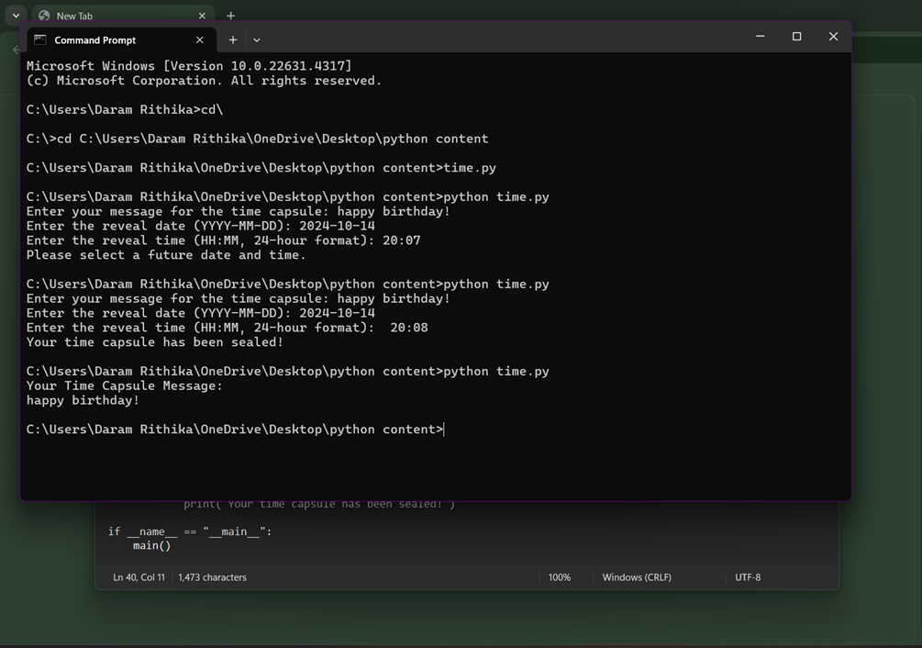

**FUTURE IMPROVEMENTS**

Future improvements for the Digital Time Capsule could include enhanced user experiences through a more intuitive interface and streamlined navigation, making it easier for users of all ages to create their capsules. Incorporating advanced AI technologies could assist in automatically organizing and tagging uploaded artifacts based on themes, dates, or locations. Expanding storage options would allow for larger files and more extensive collections, accommodating the growing demands of digital preservation. Additionally, integrating social sharing features could enable users to connect with others and share capsules more broadly, fostering community engagement. Developing mobile applications would enhance accessibility, allowing users to create and access time capsules directly from their smartphones. To increase the educational aspect, interactive tutorials and tips could be provided for storytelling and memory preservation. Implementing a multi-language support feature would broaden the platform’s reach to diverse populations globally. Enhancing data security measures and providing users with more control over visibility settings will help ensure privacy and confidence in storing sensitive materials. Lastly, incorporating feedback mechanisms could facilitate continuous improvement by gathering user input for future enhancements, aligning the platform with user needs and preferences.

**CONCLUSION**

In conclusion, the Digital Time Capsule represents a pioneering initiative to preserve and share memories that capture the essence of contemporary life for future generations. By harnessing technology, it allows individuals to document their personal narratives and cultural experiences in an engaging and accessible way. This project not only emphasizes the significance of memory preservation but also fosters intergenerational connections, enriching our understanding of shared histories. As we move forward, the continued enhancement of features and functionalities will ensure that the platform remains relevant and user-friendly. Ultimately, the Digital Time Capsule serves as a powerful tool for reflection, encouraging individuals to contemplate their legacies while contributing to a collective cultural narrative. By bridging the past and the future, it enables future audiences to connect with the richness of human experiences. This initiative invites all to participate in the creation of a lasting repository that celebrates our diverse stories. In doing so, it strengthens the bonds between generations and fosters a greater appreciation for the nuances of our shared journey. The Digital Time Capsule stands as a testament to the enduring nature of memory and the importance of preserving our human experience.

**REFERENCES**

Python Documentation: https://docs.python.org/3/ - Reference for the Python programming language.